|  |  |
| --- | --- |
| Patient Name | <Full Name> |
| CR Number | <Patient Id 1> |
| Date of Birth | <Date of Birth> |

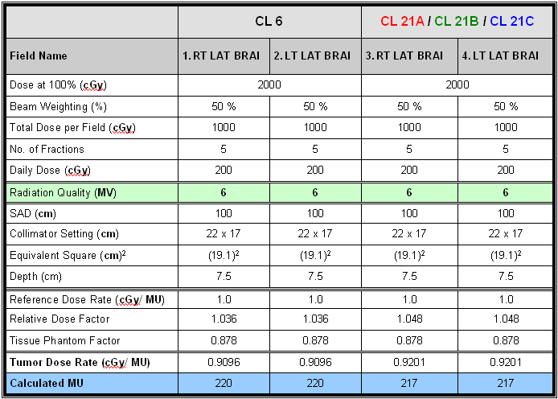

**CL21A / CL21B / CL21D / TR1**